Predictive modeling for Credit Risk

Phase 3 Report: Model Analysis and Diagnostic
Ashok Kumar Bhairwal
AAI-500 - Applied Probability and Statistics for AI | University of San Diego
June 2026
GitHub: github.com/diaeshantony-usd/applied-statistics-and-ai-team-project

Abstract
This report focuses on diagnostic evaluation and performance analysis of machine learning models for credit risk, emphasizing model behavior over development. The classification model (CatBoost) shows strong performance with an ROC-AUC of 0.9429, while PR-AUC provides better insight in the presence of class imbalance. Reliability is confirmed through calibration, with a low Brier Score of 0.0532 and well-aligned reliability diagrams.
A comprehensive diagnostic framework includes confusion matrix analysis, segment-wise error evaluation, and SHAP-based feature importance to identify key risk drivers and nonlinear effects, ensuring transparency and interpretability.
For regression models (interest rate prediction), performance is modest (maximum R² = 0.222). Residual and predicted-versus-actual analysis reveal systematic biases, including underestimation, with inconsistencies across loan grades.
Overall, the report highlights the need for a multi-dimensional diagnostic approach—combining discrimination, calibration, error analysis, and interpretability—rather than relying on a single metric.

1. Introduction

1.1 Business Context
The financial sector increasingly uses machine learning for credit risk assessment to predict defaults and guide lending. This shift supports decision-making under uncertainty and regulatory demands. Traditional models often fail to capture complex patterns, leading to inaccurate risk estimates and inefficient use of capital.

1.2 Objective
This study evaluates machine learning models for credit risk through classification (default prediction) and regression (loan parameters). It assesses performance, calibration, and errors using metrics like ROC-AUC, Precision-Recall, Brier Score, confusion matrix, and residual analysis, along with feature importance.

1.3 Significance and Scope of Report
The report highlights a comprehensive diagnostic approach beyond single metrics. It includes calibration, error analysis, and interpretability to ensure models are accurate, reliable, and aligned with real-world financial risk.

2. Related Work

2.1 Traditional Credit Risk Assessment
Credit risk assessment initially relied on expert judgment based on borrowers' financial stability, repayment capacity, credit history, and collateral. Over time, quantitative models improved consistency and objectivity. Techniques such as Linear Regression, Discriminant Analysis, and Logistic Regression became widely used to estimate default probability and support lending decisions. Regulatory frameworks encouraged standardized practices to strengthen financial stability and capital adequacy. These models offered transparency and interpretability, making them suitable for regulatory and business use.

2.2 Machine Learning-Based Credit Risk Assessment
Advances in data and computing have driven the adoption of machine learning in credit risk modeling. Algorithms such as Decision Trees, Random Forests, Gradient Boosting, XGBoost, SVM, and Neural Networks capture complex nonlinear relationships and often improve predictive accuracy. They enable automated decision-making and better risk discrimination. However, their complexity reduces interpretability, addressed through explainable AI techniques that provide insights into model behavior and feature importance. Modern approaches balance accuracy with transparency for reliable and accountable lending.

3. Method

3.1 Data preparation and Model selection:
In the data preparation phase, the credit risk dataset was cleaned by removing missing values, duplicate records, and outliers, resulting in a final dataset of 29,567 observations (from an initial 32,581). Data formats were also standardized to ensure consistency for modeling.
For model selection, the CatBoost Classifier was chosen for the default prediction task based on its superior performance. Regression models were selected to predict the loan amount, loan-to-income percentage, and interest rate.
The classification dataset was split using stratified sampling into 80% training (23,653 samples) and 20% testing (5,914 samples), preserving a default rate of approximately 22.4%. For regression, only non-default cases were considered, resulting in 18,344 training samples and 4,587 test samples. The feature set included socio-demographic attributes, financial ratios, and credit history variables.

3.2 Classification Diagnostics:
The CatBoost Classifier was evaluated across five dimensions: discriminative ability (ROC/PR curves), probability accuracy (calibration), decision-threshold analysis (confusion matrix), segment-level errors (by loan grade), and feature attribution (SHAP values).

3.2.1 ROC Curve and Precision-Recall Analysis:
The Receiver Operating Characteristic (ROC) Curve plots the True Positive Rate (TPR) against the False Positive Rate (FPR) across all possible classification thresholds. It answers the question: how well can the model distinguish defaulters from non-defaulters?
TPR indicates the Proportion of actual defaults correctly identified
TPR = TP / (TP + FN)
FPR indicates Proportion of non-defaults incorrectly flagged as defaults
FPR = FP / (FP + TN)

Precision-Recall Curve: This is very effective when class imbalance exists, It is focused only on the positive class (defaults) . . The PR curve directly measures the quality of predictions on the minority (default) class.

Precision indicates the precision of all loans predicted as default
Precision=TP / (TP + FP)​
Recall of all actual defaults
Recall = TP / (TP + FN)
Where:
- TP = Correctly predicted defaults
- FN = Missed defaults
- FP = False alarm
- TN = Correctly identified non-defaults

ROC-AUC : Area under the ROC curve
PR-AUC: Area under PR curve

3.2.2 Calibration Analysis:
Calibration Analysis assesses how closely the predicted default probabilities align with the observed
default rates.
Brier Score
The Brier Score is computed as the mean squared error between predicted probabilities and actual outcomes, it measures the accuracy of probabilistic predications:
Brier Score = (1/N) × Σ (pᵢ − yᵢ)²
where pᵢ is the predicted default probability and yᵢ ∈ {0, 1} is the actual outcome. Its value varies between 0 to 1.
Where:
• 0 = Perfect calibration
• Lower values = Better probability estimates
• Higher values = Poorer calibration
Calibration Curve Interpretation
The calibration plot shows predicted probability on the x-axis versus actual default rate in each probability bin on the y-axis. A perfectly calibrated model would follow the red diagonal. Key observations:
• Low probability range (0–0.30): Model is very slightly under-confident — actual rates slightly exceed predicted rates, but the deviation is small
• Mid range (0.30–0.60): Model shows the largest deviation from perfect calibration, common in tree-based models due to their discrete prediction structure
• High range (0.60–1.0): Model returns to near-perfect calibration, correctly identifying high-risk borrowers

3.2.3 Confusion Matrix:
A confusion matrix is a diagnostic table used to evaluate a classification model by comparing predicted labels with actual outcomes. It summarizes predictions into four categories: true positives, true negatives, false positives, and false negatives. This provides insight not only into overall model accuracy but also into the specific types of classification errors being made. The confusion matrix is particularly valuable in applications such as medical diagnosis, fraud detection, and credit risk assessment, where the cost of different errors can vary significantly. It serves as the foundation for calculating key performance metrics, including accuracy, precision, recall, and F1-score, helping assess both the effectiveness and reliability of the model.

3.2.4 Error Analysis by Loan Grade:
Error Analysis by Loan Grade is the process of evaluating a model's prediction performance separately for each loan grade (A–G) rather than looking only at overall accuracy.
In credit risk assessment, loan grades represent different risk levels:
- Grade A: Lowest-risk borrowers
- Grade G: Highest-risk borrowers
Instead of asking, "How accurate is the model overall?", error analysis asks:
- Does the model perform equally well across all risk categories?
- Which grades generate the most prediction errors?
- Are certain borrower groups systematically misclassified?
By calculating metrics such as accuracy, precision, recall, and default rates for each grade, we can identify segments where the model performs strongly or weakly.

3.2.5 Feature importance - SHAP Analysis:
SHAP (SHapley Additive exPlanations) values were computed using a TreeExplainer on a 500-sample random subset of the test data. SHAP values provide a game-theoretic decomposition of each prediction into individual feature contributions, enabling trustworthy model interpretability.
How to read the SHAP summary plot:
• Each row represents a feature, ordered by mean absolute SHAP value (top = most important)
• Each dot is one sample; horizontal position shows the SHAP value (impact on model output)
• Red dots = high feature value, Blue dots = low feature value
• Points to the right of zero increase default probability; points to the left decrease it

3.3 Regression Model Diagnostics:

3.3.1 Residual Analysis - Interest Rate
- Residuals vs. Fitted Values : Tests for non-linearity and systematic bias. Residuals should scatter randomly around the zero line with no visible pattern.
- Q-Q Plot (Normality Check) : Tests whether residuals follow a normal distribution. Points should fall on the diagonal red line.
- Residual Distribution: The residual histogram is approximately symmetric and bell-shaped, centered at mean = −0.0003 (essentially zero). This confirms the model is unbiased — it does not systematically overestimate or underestimate interest rates across the test set. The slight right skew is consistent with the heavy-tail observation in the Q-Q plot.
- Scale-Location Plot (Homoscedasticity): Tests whether the variance of residuals is constant across fitted values (homoscedasticity). Points should be roughly horizontal with constant spread.

3.3.2 Predicted vs. Actual Analysis - All Regression Targets:
Predicted Vs Actual Analysis evaluates regression performance by comparing predicted values with actual observed values. It is typically visualized using scatter plots, where the x-axis represents actual values and the y-axis represents predicted values. A 45-degree diagonal reference line indicates perfect predictions; points closer to this line reflect higher accuracy, while greater deviations represent prediction errors. This analysis provides a clear visual assessment of how well the model estimates targets such as loan amount, interest rate, and loan-to-income ratio.

3.3.3 Interest rate Prediction - Performance by loan grade:
Interest Rate Prediction Performance by Loan Grade evaluates how accurately the regression model predicts interest rates for borrowers within each loan grade (A–G). Since loan grades reflect different levels of credit risk, this analysis helps determine whether prediction accuracy varies across risk segments.
The objective is to answer questions such as:
- Does the model predict interest rates equally well across all loan grades?
- Which grades have the highest prediction errors?
- Does performance deteriorate for higher-risk borrowers?
Typically, metrics such as Mean Absolute Error (MAE) and Standard Error are calculated for each grade. Lower values indicate more accurate predictions.

3.3.4 Feature Importance SHAP analysis (Interest RateModel)
SHAP analysis for the interest rate regression model reveals which borrower attributes most strongly drive interest rate assignments. Prior default history dominates, reflecting the fundamental credit pricing principle that higher historical risk commands higher rates.

4. Results

4.1 Classification

4.1.1 ROC Curve and Precision-Recall Analysis
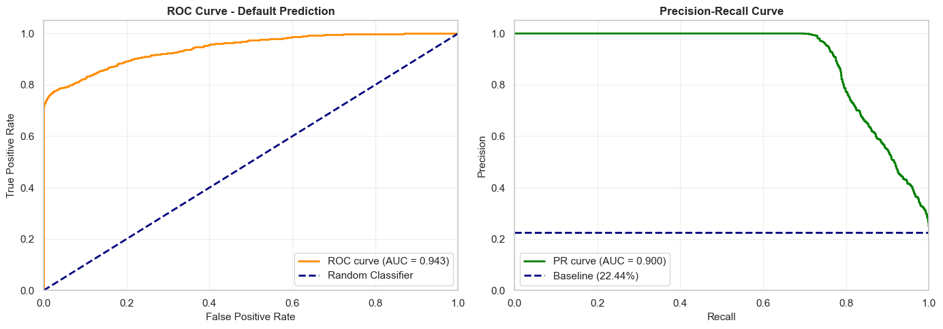
The model achieved a ROC-AUC of 0.9429, which is classified as excellent (> 0.85). This means there is a 94.29% probability that, given a random defaulter and a random non-defaulter, the model will assign a higher risk score to the defaulter. The curve rises steeply toward the top-left corner — far above the diagonal random-classifier baseline — confirming strong discriminative ability across all threshold settings
The model achieved a PR-AUC of 0.9003. The curve stays at near-perfect Precision (≈1.0) for Recall values up to about 0.70, then gradually decreases. This means the model can detect up to 70% of defaults without making any false-positive predictions — an exceptional result for a credit risk use case where false positives (wrongly denying a good borrower) carry real business cost.

4.1.2 Calibration Analysis (Reliability Diagram)
The model achieved a Brier Score of 0.0532, indicating excellent calibration. Its predictions are both directionally strong and numerically reliable.
The calibration plot shows predicted vs. actual default rates, with the ideal model following the diagonal line. The model is slightly under-confident at low probabilities, deviates most in the mid-range (common for tree-based models), and regains near-perfect calibration at higher probabilities, effectively identifying high-risk cases.

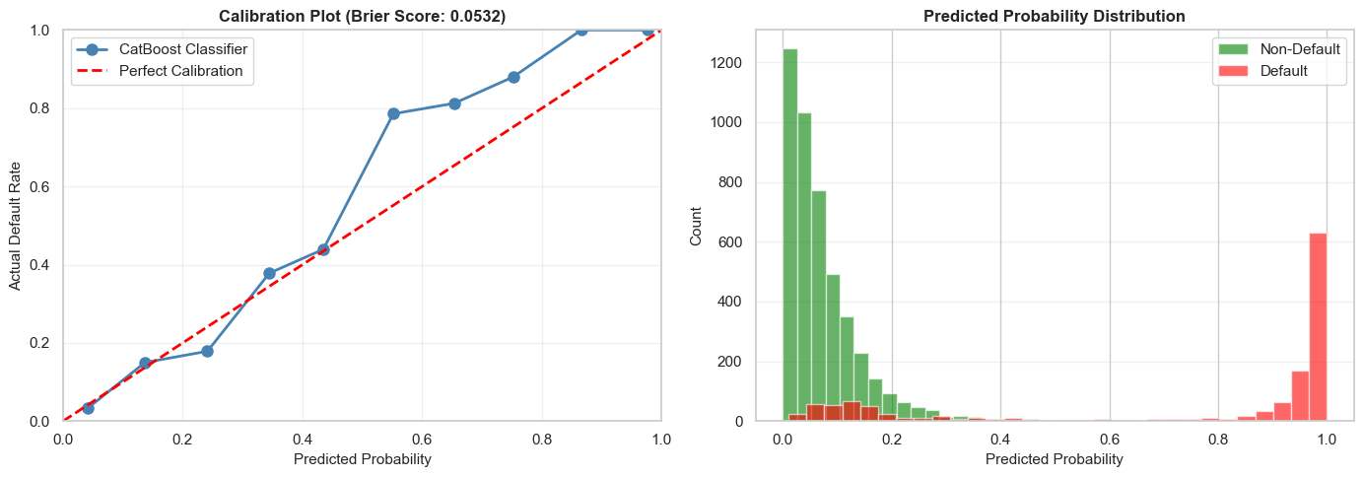

Metric | Value | Threshold | Assessment
Brier Score | 0.0532 | < 0.15 = well-calibrated | Excellent
Mean Calibration Error | 8.00% | < 10% = good | Good
Calibration Range | 0.0–1.0 | Full range covered | Complete

4.1.3 Confusion Matrix (Multi-Threshold Evaluation):
The classification threshold controls how predicted default probabilities are converted into binary decisions. Three thresholds were evaluated to balance precision and recall:
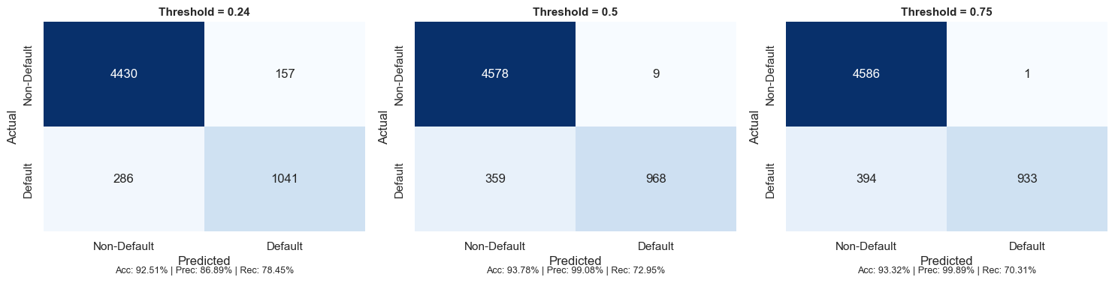

Threshold | TN | FP | FN | TP | Accuracy | Precision | Recall | F1-Score
0.24 (Aggressive) | 4,430 | 157 | 286 | 1,041 | 92.51% | 86.89% | 78.45% | 0.8246
0.50 (Balanced) | 4,578 | 9 | 359 | 968 | 93.78% | 99.08% | 72.95% | 0.8403
0.75 (Conservative) | 4,586 | 1 | 394 | 933 | 93.32% | 99.89% | 70.31% | 0.8253
Interpretation:
- 0.24 (Aggressive): Achieved the highest recall (78.45%), identifying more defaulters but generating more false positives (157). Suitable for risk-averse lending strategies.
- 0.50 (Balanced): Delivered the best overall performance with the highest F1-score (0.8403) and accuracy (93.78%), while keeping false positives low (9) and maintaining strong recall (72.95%). This represents the optimal threshold for most credit risk applications.
- 0.75 (Conservative): Produced near-perfect precision (99.89%) with only 1 false positive, but reduced recall to 70.31%, resulting in more missed defaults. Appropriate when false positives are extremely costly.
Overall, the 0.50 threshold provides the most effective balance between identifying defaulters and minimizing incorrect rejections of creditworthy borrowers.

4.1.4 Error Analysis by Segments:
Model performance was evaluated across loan grades (A–G) to determine whether predictive accuracy varied by borrower risk level. Overall accuracy remained consistently high across all grades, ranging from 89.70% to 100.00%, with an average accuracy of 94.43%.

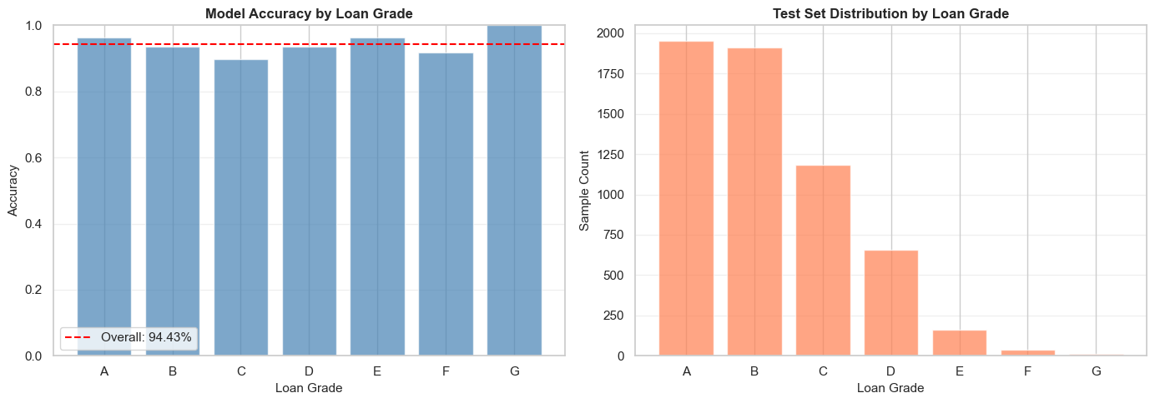
Key observations include:
- Grade A achieved strong performance (96.41% accuracy) due to its low default rate (10.20%) and clear separation between default and non-default borrowers.
- Grade C was the most challenging segment (89.70% accuracy), as its moderate default rate (20.86%) created greater overlap between classes.
- Grades E–G showed very high accuracy (91.67%–100.00%) because defaults dominate these segments, making classification more straightforward.
- Although Grade G achieved 100% accuracy, the result is based on only 12 samples and should be interpreted cautiously.
The grade distribution was highly imbalanced, with Grades A and B accounting for most test cases, while Grades F and G contained very few observations. Consequently, performance estimates for the highest-risk grades are less reliable due to limited sample sizes.
Overall, the model demonstrated robust and stable performance across all risk segments, maintaining accuracy above 89% for every loan grade.

4.1.5 Feature Importance — SHAP Analysis (Classification)
Asas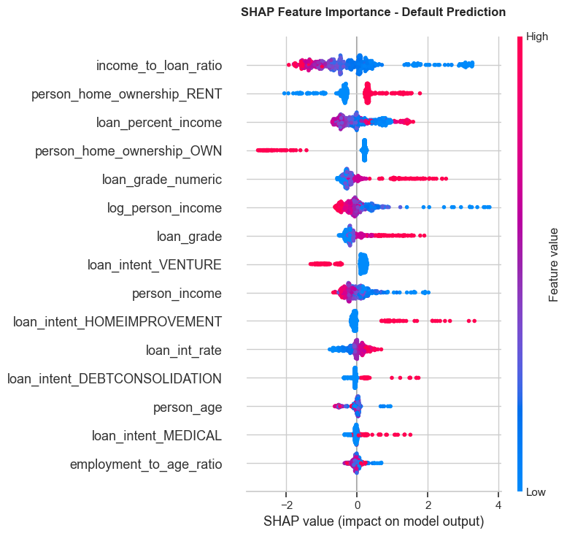

Rank | Feature | Direction of Effect | Business Interpretation
1 | income_to_loan_ratio | High ratio → lowers default risk | Borrowers who earn much more than they borrow are lower risk
2 | person_home_ownership_RENT | Renting → increases default risk | Renters have less asset stability and face higher default probability
3 | loan_percent_income | High burden → increases risk | Loans consuming a large share of income are harder to repay
4 | person_home_ownership_OWN | Owning → lowers default risk | Homeowners have demonstrated financial stability
5 | loan_grade_numeric | Higher grade → increases risk | Lower credit grades (D–G) correlate strongly with default
6 | log_person_income | Higher income → lowers risk | Higher earners are generally better positioned to repay
7 | loan_grade | Lower grade → increases risk | Corroborates loan_grade_numeric finding
8 | loan_intent_VENTURE | Venture loans → increases risk | Business/venture loans carry higher risk than personal loans
9 | person_income | Higher income → lowers risk | Consistent with log_person_income effect
10 | loan_intent_HOMEIMPROVEMENT | Home improvement → increases risk | Borrowers improving homes may be stretching financial capacity

The SHAP analysis confirms that the most powerful predictors of default are economic leverage metrics (income-to-loan ratio, loan burden) and credit risk indicators (loan grade, prior default history). Home ownership status acts as a significant proxy for financial stability. Notably, the model relies on engineered features (income_to_loan_ratio, log_person_income) almost as heavily as raw features — validating the Phase 2 feature engineering effort .

4.2 Regression Model Diagnostics

4.2.1 Residual Analysis – Interest Rate Model
Residual analysis evaluates whether prediction errors are random or indicate systematic issues in the regression model. The 4-panel diagnostic plot shows that the model is generally unbiased, with residuals centered around zero and no significant over- or under-prediction.
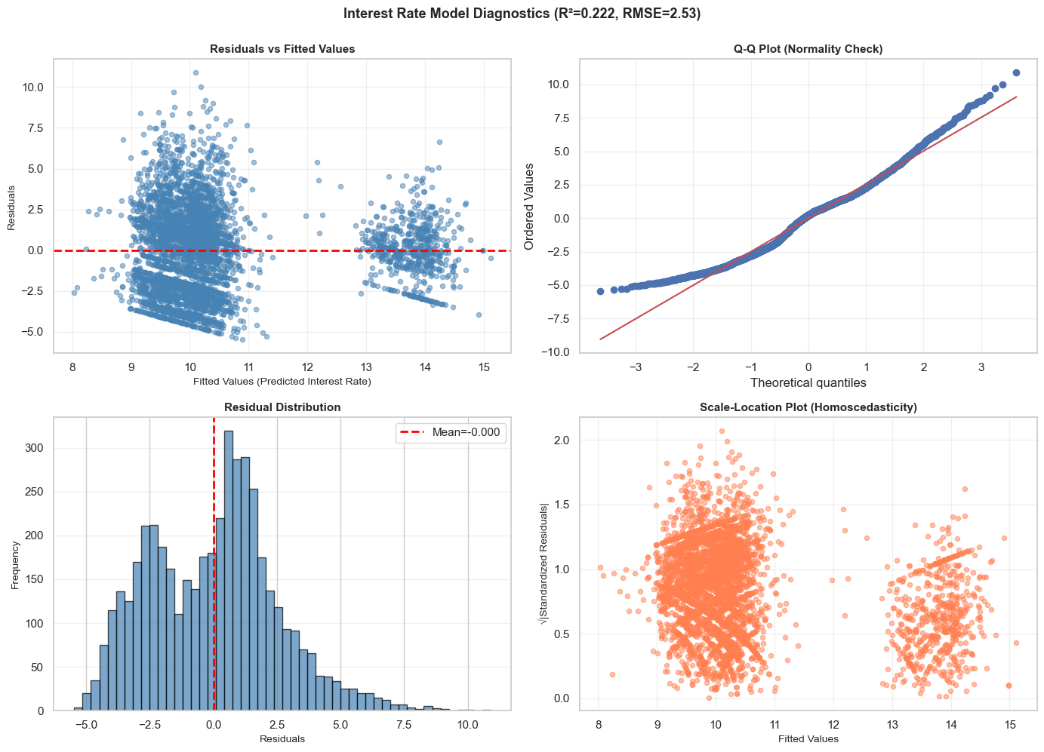
Key findings include:
- Residuals vs. Fitted Values: Residuals are randomly distributed, indicating no major non-linearity. A wider spread for higher interest rates (Grades D–F) suggests mild heteroscedasticity.
- Q-Q Plot: Residuals are approximately normally distributed, although heavier tails indicate occasional large prediction errors.
- Residual Distribution: The histogram is nearly symmetric and centered at zero (mean = -0.0003), confirming the absence of systematic bias.
- Scale-Location Plot: Residual variance increases slightly at higher predicted rates, indicating mild non-constant variance.

Metric | Value | Benchmark | Assessment
R² Score | 0.2223 | Higher = better | Explains 22.23% of variance — moderate
MAE | 2.0557% | Lower = better | Average error of ~2.06 percentage points
RMSE | 2.5305% | Lower = better | Penalizes large errors more than MAE
MAPE | 22.51% | Lower = better | Average relative error of 22.51%
Residual Mean | -0.0003 | Should be ~0 | Excellent — no systematic bias
Residual Std | 2.5308% | Lower = better | Consistent with RMSE
Mean Rate | 10.42% | Context | Average actual interest rate
Overall, the model explains 22.23% of interest rate variation (R² = 0.222) with an RMSE of 2.53% and MAE of 2.06%. While predictive accuracy is moderate, the residual diagnostics suggest that the model satisfies most regression assumptions and produces unbiased interest rate estimates.

4.2.2 Predicted vs. Actual Analysis — All Regression Targets:
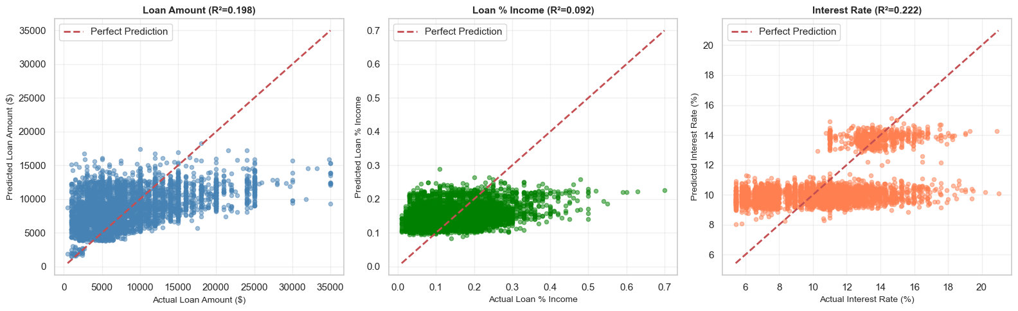

Target | R² | MAE | RMSE | MAPE | Assessment
Loan Amount | 0.1978 | $3,869 | $5,048 | 73.7% | Moderate — use with caution
Loan % Income | 0.0918 | 0.065 | 0.082 | 73.9% | Moderate — limited power
Interest Rate | 0.2223 | 2.056 p.p. | 2.531 p.p. | 22.5% | Moderate — best of three

Loan Amount (R² = 0.198, MAPE = 73.7%)
The model captures the general trend but lacks precision, with predictions clustering around average loan values and systematically underestimating large loans. The high MAPE indicates limited suitability for precise loan amount estimation.
Loan % Income (R² = 0.092, MAPE = 73.9%)
This is the weakest regression model, explaining less than 10% of the variance. Predictions are concentrated within a narrow range and frequently underestimate high loan-to-income ratios, resulting in poor predictive power.
Interest Rate (R² = 0.222, MAPE = 22.5%)
The interest rate model performs best, showing the strongest alignment between predicted and actual values. It effectively captures grade-based interest rate patterns, though prediction errors increase for higher-risk loans due to greater variability and fewer training samples.
Overall, all three models exhibit moderate predictive performance, with the interest rate model providing the most reliable estimates, while loan amount and loan-to-income ratio predictions should be interpreted cautiously.

4.2.3 Interest Rate Prediction Performance by Loan Grade
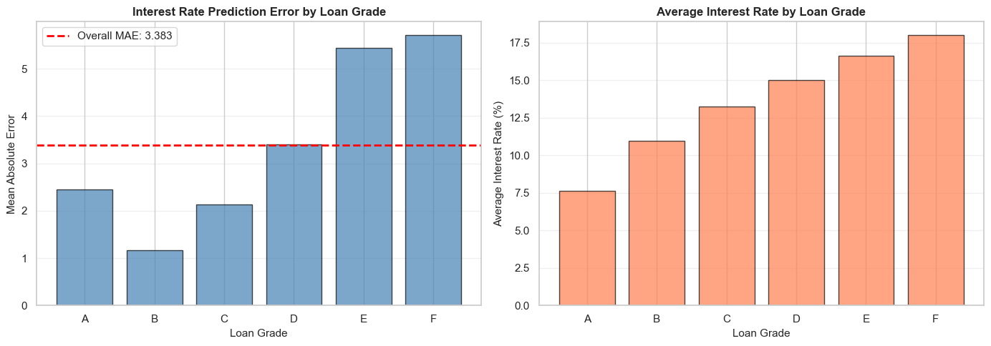
This analysis evaluates how accurately the model predicts interest rates across different borrower risk grades.
Loan Grade | Mean Rate | MAE (p.p.) | Std Error | Sample Count | Relative Error
A | 7.63% | 2.457 | 1.141 | 1,809 | 32.2%
B | 10.98% | 1.166 | 0.783 | 1,570 | 10.6%
C | 13.26% | 2.128 | 1.533 | 872 | 16.1%
D | 14.99% | 3.401 | 2.223 | 262 | 22.7%
E | 16.62% | 5.440 | 2.448 | 58 | 32.7%
F | 17.99% | 5.708 | 2.670 | 16 | 31.7%
Key findings:
- Grade B achieved the best performance (MAE = 1.17 percentage points), benefiting from a large sample size and consistent rate patterns.
- Grade A showed higher error (MAE = 2.46 p.p.) due to greater variation in interest rates within the grade.
- Grades E and F had the largest errors (MAE = 5.44–5.71 p.p.), largely because of limited training data and greater rate variability.
- Prediction error generally increases with borrower risk, indicating that higher-risk grades are more difficult to model accurately.
Overall, the model achieved an average MAE of 3.38 percentage points, with performance strongest for Grade B and weakest for Grade F. This suggests the model is most reliable for low- to medium-risk borrowers and less precise for high-risk segments.

4.2.4 Feature Importance — SHAP Analysis (Interest Rate Model)

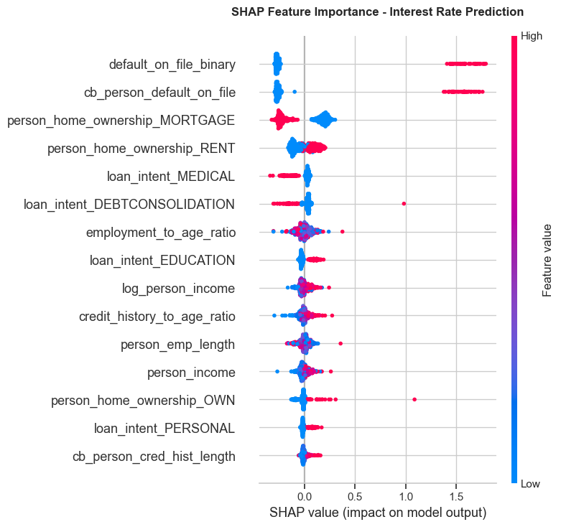

Rank | Feature | Effect Direction | Business Interpretation
1 | default_on_file_binary | Prior default → higher rate | Strongest signal: borrowers with any prior default are assigned significantly higher rates
2 | cb_person_default_on_file | Prior default → higher rate | Credit bureau confirmation of prior default — nearly identical effect to binary version
3 | person_home_ownership_MORTGAGE | Mortgage → lower rate | Mortgage holders demonstrate creditworthiness; lenders offer lower rates
4 | person_home_ownership_RENT | Renting → higher rate | Renters perceived as higher risk; pay premium interest rates
5 | loan_intent_MEDICAL | Medical → lower rate | Medical loans may be viewed as unavoidable necessity; some lenders offer lower rates
6 | loan_intent_DEBTCONSOLIDATION | Debt consolidation → higher | Consolidating debt signals existing financial stress; higher rates applied
7 | employment_to_age_ratio | Higher ratio → moderate effect | Employment stability relative to age signals career trajectory
8 | loan_intent_EDUCATION | Education → lower rate | Education loans often have government backing or preferential rates
9 | log_person_income | Higher income → lower rate | Higher earners qualify for lower interest rates due to lower default risk
10 | credit_history_to_age_ratio | Longer history → lower rate | Longer credit history relative to age signals financial maturity

The SHAP plot reveals two distinct groups of important features: (1) prior default history features (default_on_file_binary, cb_person_default_on_file) with large, asymmetric SHAP distributions concentrated on the right side — indicating they push rates significantly higher when present but have limited effect when absent; and (2) housing and income features with more symmetric distributions, acting as moderating factors across the full borrower spectrum.

5. Conclusion

5.1 Classification Model — CatBoost Classifier
The CatBoost default prediction model demonstrates excellent performance across every diagnostic dimension evaluated:
Diagnostic | Metric | Value | Threshold | Assessment
Discrimination | ROC-AUC | 0.9429 | > 0.85 | Excellent
Imbalance Perf. | PR-AUC | 0.9003 | > 0.70 | Strong
Calibration | Brier Score | 0.0532 | < 0.15 | Excellent
Calibration | Mean Calibration Error | 8.00% | < 10% | Good
Accuracy | Test Accuracy (t=0.50) | 93.78% | > 90% | Good
Precision | Precision (t=0.50) | 99.08% | > 95% | Excellent
Recall | Recall (t=0.50) | 72.95% | > 70% | Good
Segment Perf. | Min Grade Accuracy | 89.70% | > 85% | Good (Grade C)

The model is production-ready. Key strengths include: (a) near-perfect Precision at threshold 0.50 (99.08%), meaning virtually no creditworthy borrowers are incorrectly denied; (b) strong recall (72.95%) catching nearly 3 in 4 actual defaults; (c) excellent calibration enabling use of raw probabilities for risk-based pricing; and (d) consistent performance across all 7 loan grade segments.
• Primary top features: income_to_loan_ratio, loan_percent_income, loan_grade
(confirmed by SHAP)
• Recommended deployment threshold: 0.50 (best F1 = 0.8403)
• Monitoring requirement: Track calibration drift and grade-level accuracy quarterly

5.2 Regression Models — Performance Summary

Model | R² | MAE | MAPE | Residual Bias | Assessment | Deployment Recommendation
Loan Amount | 0.198 | $3,869 | 73.7% | ~0 (unbiased) | Moderate | Use as approximate estimate only; ±$5K confidence interval recommended
Loan Percentage Income | 0.092 | 0.065 | 73.9% | ~0 (unbiased) | Weak | Exploratory use only; not recommended for operational decisions
Interest Rate | 0.222 | 2.06 p.p. | 22.5% | ~0 (unbiased) | Moderate (best) | Suitable for rate banding; pair with Grade-based adjustments

All three regression models are unbiased (residual mean ≈ 0) and residual diagnostics satisfy basic assumptions. However, R² values between 0.09 and 0.22 indicate that the available features explain only a limited portion of the variance in loan amounts and loan-to-income ratios. These quantities are heavily influenced by lender policies, borrower negotiation, and market conditions not captured in the dataset.

Recommended improvements for regression models:
• Feature engineering: Add credit score bins, employment industry, geographic region, and loan purpose subcategories
• Modeling: Explore quantile regression for prediction intervals, or hierarchical models stratified by loan grade
• Data: Collect lender-side features (loan offer vs. acceptance) and macroeconomic indicators (prevailing rate environment)

End of Phase 3 Report — Model Analysis and Diagnostic
Ashok Kumar Bhairwal | AAI 500 | University of San Diego | June 2026

